**REQUIREMENTS:**

MatLab + Image processing toolbox

The following code files: loadtiff.m / saveastiff.m / getdir.m / split.m / diameter.m / NVC.m

Before starting, make sure that the folder with the codes is loaded into MatLab (SetPath)

**STEP 1: Separation of both penetrating arterioles (PAs) into single images and classification in individual folders:** the original images come with two PAs per picture, thus we need to separate them to analyze the diameter.

1. Open MatLab
2. In the window of “current folder”, open the folder in which you want to save the pictures. This is the destination folder.
3. *>> getdir* to get the directory where the images are. A window will pop, then you have to select the origin folder.
4. *>> split* will divide the original picture into two independent PAs. The images with the two independent PAs will be saved in the destination folder.
5. Remember to arrange the PAs in individual folders to go through the next step. It means, 1 folder should contain the 10 replicates of 1 PA, only. No mixed PAs in the same folder.

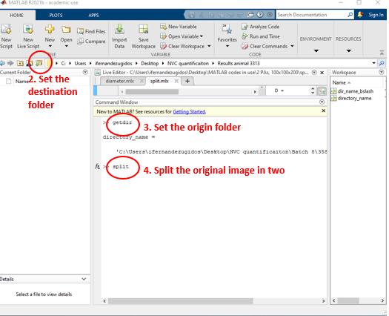

**STEP 2: Measuring the diameter of every individual PA.** This code will filter and binarize the image and will measure the minimum diameter of the PA in the stack of 200 images.

1. *>> clear all* cleans all the previous stored files
2. Set up the destination folder (same as origin folder: where the PAs are)
3. *>> getdir* to set up the origin folder (where the PAs are)
4. *>> diameter* to process the image and measure the diameter of every single PA picture. You have to run it for every PA replicate, in all the PAs.

Outputs: a window with the binarized image will show up, and it will save three files

* 1. .tiff file with the filtered image (ending in _adj.tiff)
  2. .tiff file with the binarized image (ending in _bin.tiff)
  3. .mat file with the diameter of the 200 frames, one row per frame (ending in _Diameter.mat)

1. Before going to the next step, close the window with the binarized image and clean the code with >> clear all.

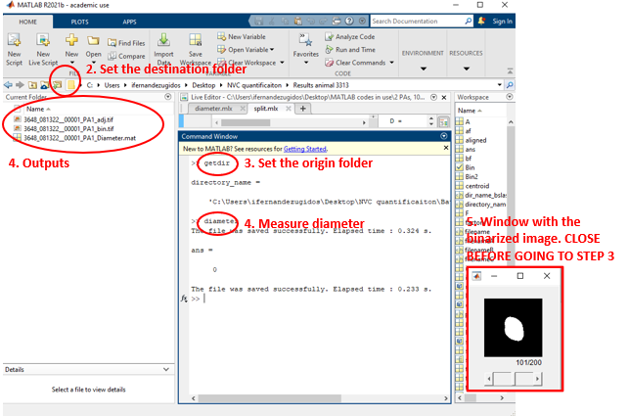

**STEP 3: Obtaining the NVC values.** Now we have individual folders per every PA and timepoint, meaning that in every folder there are 10 replicates inside with all the .mat files with the diameters of every replicate. The following code will average the 10 replicates and will obtain the values of the NVC. Moreover, it will plot the traces of every single replicate (thin trace) and the average (thick trace).

1. *>> clear all* to clean previous residual codes
2. Make sure that the window with the binarized image is closed.
3. Set the destination folder
4. *>> getdir* to set the origin folder
5. *>> NVC* to run the code. The output will be:
   1. A window with the plot of every single trace (thin) and the averaged trace (thick).
   2. A display of the results in the MatLab window (see screenshot)
   3. Three files in the folder:
      1. A file ending in _perc.mat <-mat file showing the % values of the diameter
      2. A file with the basename of the PA ending in .mat <-mat file showing the absolute values of the diameter
      3. A file with the basename of the PA ending in .png <- image file showing the plots
6. Copy and paste the values in your excel file
7. Before starting with a new PA, clear all the windows with *>> clear all*

NOTE: If you want to re-run the NVC values calculation in the same PA but eliminating any of the 10 replicates, you first must delete the three files that were obtained (described in 5c, and showed in the screenshot).

